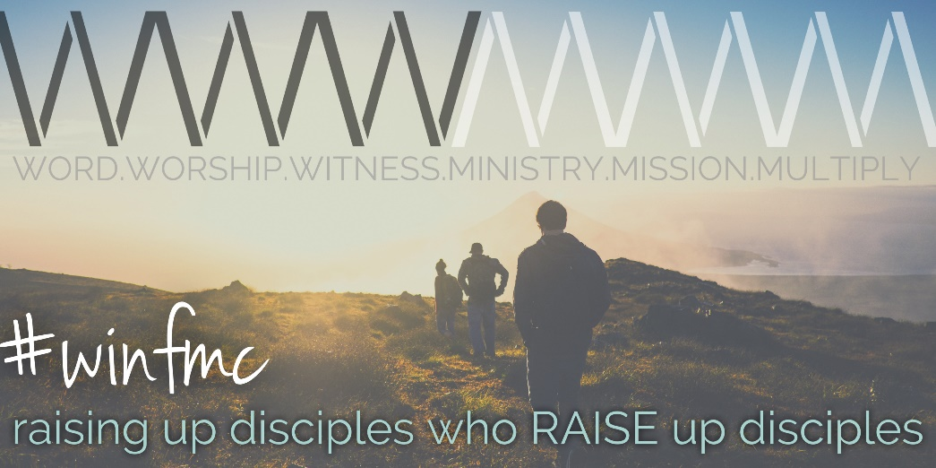
Discipleship Groups are same-gender groups of 3 to 4 individuals that meet for 1 hour a week, from Sept. to May.

During their nine months together Discipleship Groups cover six areas of discipleship;
- Word: How will I fill my mind with truth?
- Worship: How will II fuel my affections for God?
- Witness: How will I share God's love as a witness?
- Ministry: How will I show God's love to others?
- Mission: How will I spread God's glory to the world?
- Multiply: How will I make disciple-makers?

Discipleship is a lifelong journey of pursuing Jesus Christ and helping others to do the same. Disciples are, above all, committed to Jesus Christ as their Savior and Lord.

Individuals desiring to join a discipleship group will commit…
- to Praying daily
- to Reading Scripture regularly
- to Pursuing a deeper relationship with Christ
- to Making weekly discipleship meetings a priority
- to Open and honest accountability
- to Calling others into discipleship

Would you commit to being a part of a Discipleship Group?

more info here: http://bit.ly/winfmcdiscipleship
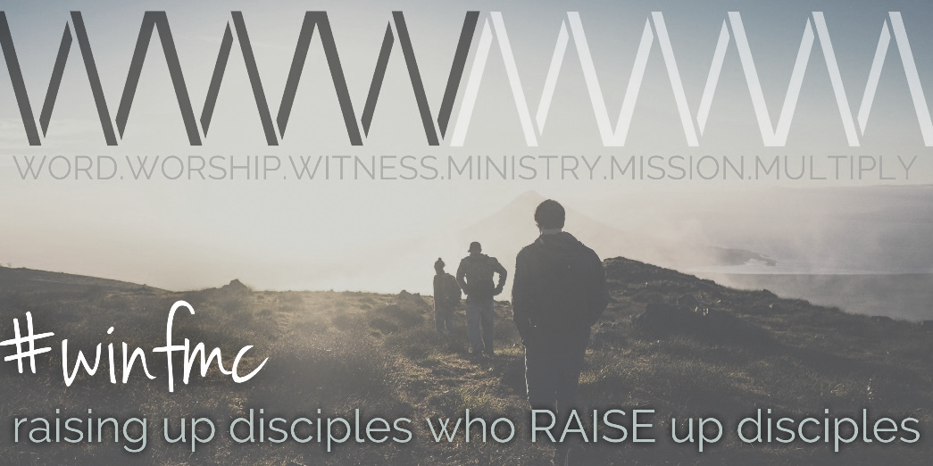
Discipleship Groups are same-gender groups of 3 to 4 individuals that meet for 1 hour a week, from Sept. to May.

During their nine months together Discipleship Groups cover six areas of discipleship;
- Word: How will I fill my mind with truth?
- Worship: How will II fuel my affections for God?
- Witness: How will I share God's love as a witness?
- Ministry: How will I show God's love to others?
- Mission: How will I spread God's glory to the world?
- Multiply: How will I make disciple-makers?

Discipleship is a lifelong journey of pursuing Jesus Christ and helping others to do the same. Disciples are, above all, committed to Jesus Christ as their Savior and Lord.

Individuals desiring to join a discipleship group will commit…
- to Praying daily
- to Reading Scripture regularly
- to Pursuing a deeper relationship with Christ
- to Making weekly discipleship meetings a priority
- to Open and honest accountability
- to Calling others into discipleship

Would you commit to being a part of a Discipleship Group?

more info here: http://bit.ly/winfmcdiscipleship

